Laycee Glass
NVM4 Task 1
Data Mining I
1/11/25
Western Governors University

NVM4 Performance Assessment, Task 1

Student Information
Student Name: Laycee Glass
ID Number: 001896026
Date: 1/11/25

Part I: Research Question

A1. Question
The question I set out to answer for this task was the following: Can we predict if a patient will be readmitted to the hospital or not?

A2. Goal of Analysis
The goal for this analysis was to predict if a patient would be readmitted to the hospital based on predictor variables.

Part II: Method Justification

B1. Classification Method
The classification method used here was k-nearest neighbors (KNN). This method makes no assumptions about the underlying data distribution. Its main mechanism is distance. Based on the distance of given data, the model will then make predictions.
In this case, trying to classify new rows as readmission vs not was based on where the predictor variables were placed in relation to the already known data.
KNN uses a “k” value that must be chosen to represent the number of neighbors. A higher “k” may overfit the data which would smooth out noise but ignore local details. A smaller “k” may underfit the data which would, in contrast, focus on the local details but retain noise (What is K-Nearest Neighbor, n.d.).

B2. Assumption
To use KNN, we must assume a closeness of data points. This closeness means that similar instances have similar outcomes. If the closeness doesn’t reflect relationships, the model will be useless.

B3. Packages/Libraries
For this task, many packages and libraries were used in Python. They are as follows:

- pandas: handling and preprocessing datasets
- numpy: numerical computations and array manipulation
- scikit-learn: core library for KNN and other machine learning algorithms
- matplotlib and seaborn: creating visualizations
- scipy: contains distance metrics
- statsmodels: provides statistical tests and functions to analyze data

Part III: Data Preparation

C1. Preprocessing Goal
The main goal of preprocessing for this task was to re-epxress the categorical variables and scale the continuous data. KNN only deals with binaries, so the variables needed to be re-expressed by one hot encoding. The continuous variables were scaled using StandardScaler.
Besides this, some minor cleaning tasks were completed just for ease of use. All of the code for this is discussed more in depth later on (C3).

C2. Variables
The variables included in this task were the following:

Dependent variable:
- ReAdmis (binary categorical)

Independent, categorical variables:
- Gender
- Soft_drink
- Initial_admin
- HighBlood
- Stroke
- Complication_risk
- Overweight
- Arthritis
- Diabetes
- Hyperlipidemia
- BackPain
- Anxiety
- Allergic_rhinitis
- Reflux_esophagitis
- Asthma

Independent, continuous variables:
- Children
- Age
- VitD_levels
- Doc_visits
- Full_meals_eaten
- vitD_supp
- Initial_days

C3. Preparation Steps and Code
In order to create the KNN model, some data preparation needed to be done. The first thing I did was drop all the columns that were irrelevant for our purposes. This code is shown below:
The next steps were to clean the data in the same manner as previous tasks. This meant identifying any nulls and outliers (and subsequently visualizing these) in the data. This code, the same from previous courses, is shown below:
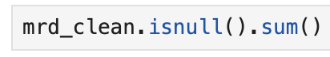

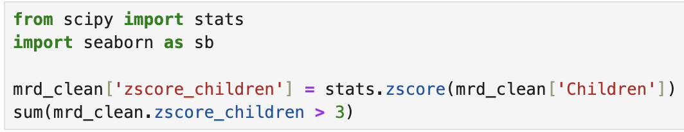

No nulls were present, and the outliers were expected so they were retained.

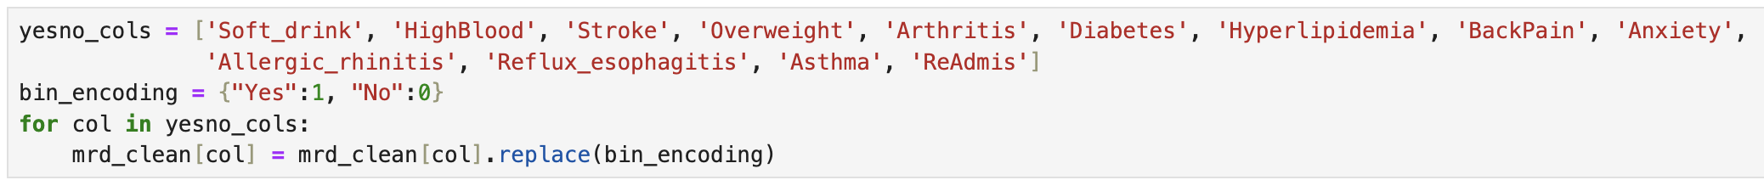
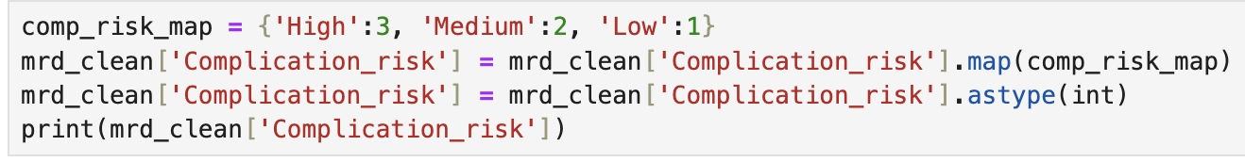
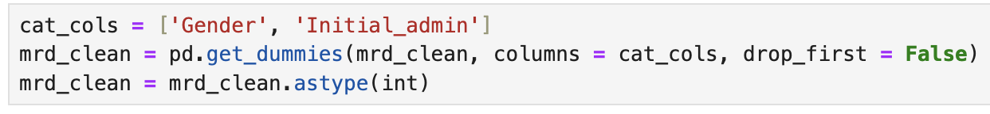
As stated earlier, the categorical variables needed to be re-expressed. This was done through one hot encoding and mapping. This was simple for variables with “Yes”/“No” values, but for variables with more than this, one hot encoding created dummy variables for each of the values. From here, 0/1 was assigned to indicate whether the value was present or not. This code is shown below:

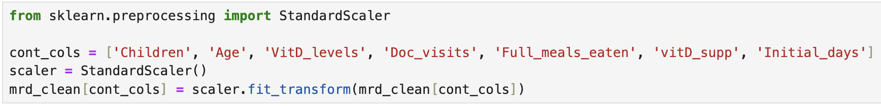
After this, the continuous data needed scaled for KNN purposes. This is due to KNN being a distance based algorithm. I used StandardScaler() because it puts all features on the same scale. The code for this process is shown below:

Once the data had been scaled, the best features to use for the KNN model were found using SelectKBest. This method identified variables whose p-values were less than 0.05, the standard threshold of determining statistical significance. The code for this is shown below:
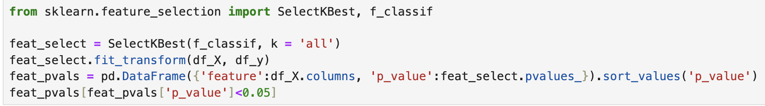

There ended up being three significant features, which were initial_days (how many days the patient stayed during admission), children (number of children), and initial_admin_ema (emergency admission). So our set of variables was reduced from 27 down to 3.

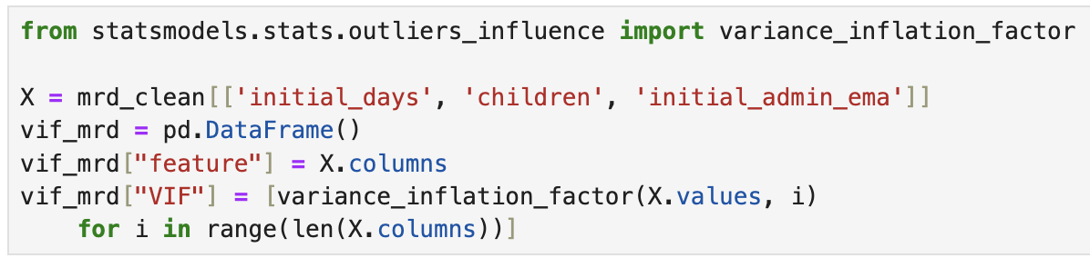
To check for any multicollinearity issues within the significant variables, variance inflation factor was performed. The code for this is shown below (along with its output):
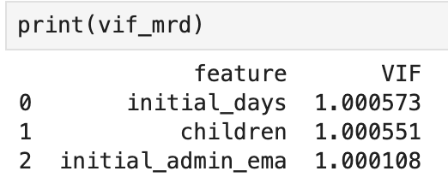

Because none of the VIF values were greater than 5, they were all retained in the model.

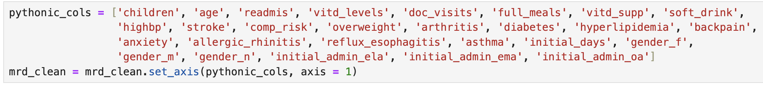
Finally, the columns were renamed for ease of use. This code is shown below:

C4. Copy of Dataset
A copy of the cleaned and prepared data has been attached with this submission. The code for exporting the data is shown below:

Part IV: Analysis

D1. Train/Test Split
The data was split into training and testing sets using a 70/30 split. This means that 70% of the data was randomly assigned to the training set. This set helped the model discover patterns and relationships in the data that helped with predictions. The remaining 30% then became the test set. The code for splitting the data is shown below (along with the code showing what df_X and df_y contained):
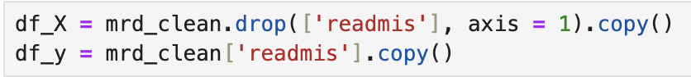

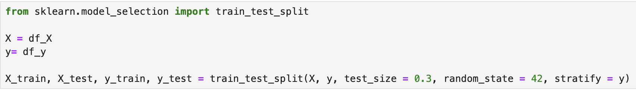

D2/3. Analysis Technique and Code
To perform KNN, we had to find the best “k” value for our data using the GridSearchCV method which involved trying different values of “k” and searching the results to find the most accurate model. Using the .best_params_ function, we saw what our optimal “k” value was: 30. And we saw how accurate it was using .best_score_. The code and subsequent output for this is shown below:

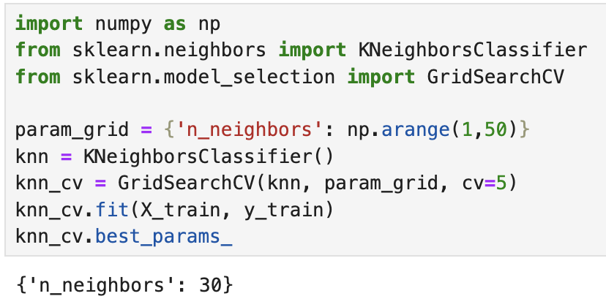

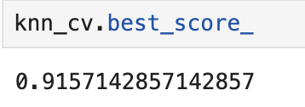

As found above, our “k” value was 30. I then input this to set up our model and run it. Once the model was created with our best parameters, I also created a confusion matrix to evaluate the model’s performance. The code and subsequent output for this is shown below:
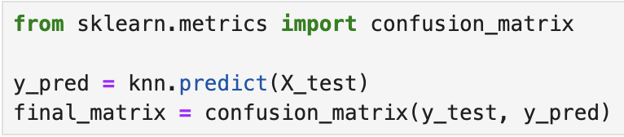

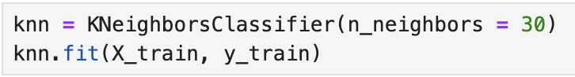
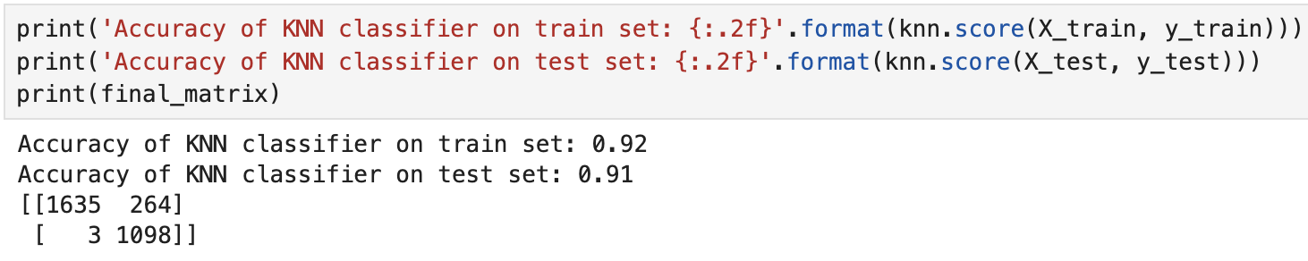

Part V: Data Summary and Implications

E1. Accuracy and AUC Score
Analyzing the accuracy of our model was done in several ways. The first was the aforementioned confusion matrix, from which we got an accuracy score. Per our confusion matrix, the model accurately predicted 2733 outcomes (1635 true positives and 1098 true negatives) out of 3000 total outcomes. This was, as calculated in the output, an accuracy score of 91%.
Another way to determine the accuracy was through the receiver operating characteristic (ROC) curve and area under the curve (AUC) score. The ROC curve is a graph that represents the model’s performance by plotting the false positive rate on the x-axis and the true positive rate on the y-axis. The line y=x (shown in the visual as a dotted line) represents a random classifier of 50% accuracy. The upper left corner represents an ideal classifier with 100% sensitivity.
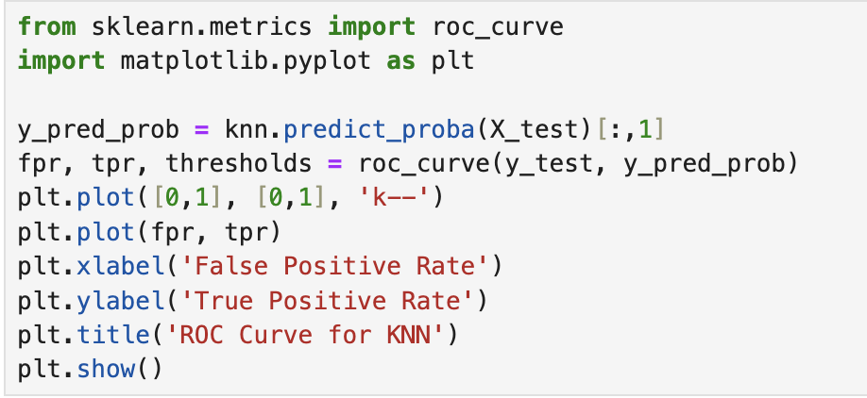
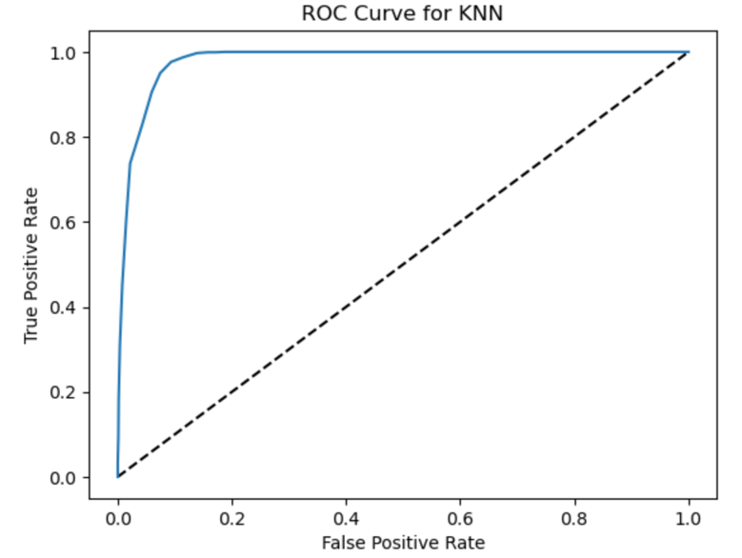
As seen, our model was close to this ideal classifier, indicating a very strong performance of accurately classifying true positives. The AUC score is the actual metric that measures the curve. The score represents the ability of the model to distinguish between classes. A score of 1.0 would be a perfect model, whereas a score of 0.5 would mean the model is no better than guessing randomly. Our model had an AUC score of 0.979687669420842, once again indicating excellent performance (Auc Roc Curve, 2025). These metrics, and the code for them, are shown below:

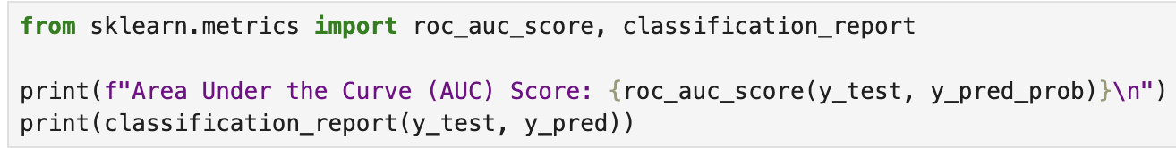
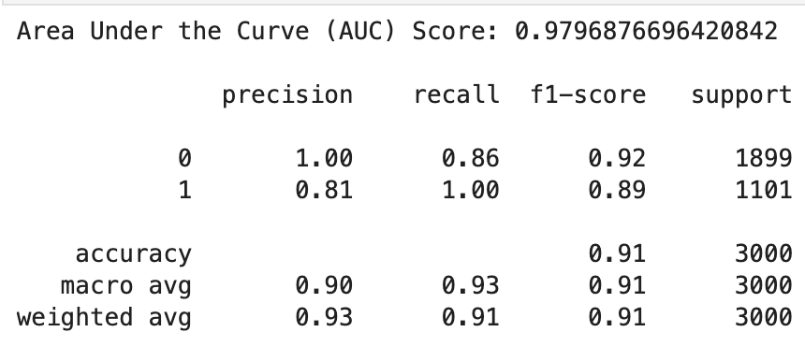

E2. Results and Implications
Similar to the logistic regression model created in D208 for a very similar question, the KNN model performed exceptionally well. The 91% accuracy score means it’s generally reliable, and the 0.9797 AUC score means it’s almost perfect at distinguishing between positive and negative cases.
In a real-world health care setting, a 91% accuracy score may suggest a generally reliable model, but it should not be the sole decision-making tool. A 9% error rate may seem small, but in healthcare, every misclassification could have significant consequences. Missing a true readmission case could lead to worsened health outcomes and higher long-term costs, whereas incorrectly predicting a readmission could result in improper resource allocation.
The model’s 0.9797 AUC score indicates it is effective at predicting a readmission/not. However, simply predicting is just one small piece of the bigger picture. Understanding the “why” is just as important, if not more. For example: Why are certain patients higher risk? Why do certain conditions increase likelihood of readmission? Why do age/gender play a role? KNN excels at predicting but lacks context needed to provide insights to health care professionals in order to make changes to care/cost strategies.

E3. Limitation
Although the model seemed to perform very well and had a relatively high accuracy score, this alone is not sufficient for real-world application. In our case, the model was great at predicting a readmission vs not but this could be misleading. If the data was imbalanced (if out of 1000 patients, 900 were readmitted), then the model could predict every patient was readmitted and still have a 90% accuracy score. The model also does not indicate which factors are most important to readmission or give any insight into why they are being readmitted (11.4 advantages, n.d.).

E4. Real World Action
Based on everything so far, my suggestion would be to get more data. In almost all cases, more data means more features leading to better context. Getting more data such as symptom/condition severity, initial complaints, past medical history, etc. would help the model accuracy by adding more predictive features.
More data also helps with better generalization. As our current data has no individuals under the age of 18, this means the model works well for all populations but them. Adding data for patients under 18 would lead to a more comprehensive model for all age categories.
Finally, I would suggest using the model in conjunction with other models such as decision trees and logistic regression to give a better overall picture as to who is being readmitted/not and why.

Part VI: Demonstration

F1. Panopto Recording
A Panopto recording showing code execution and functionality has been submitted alongside this report.

G. Code Sources
D209 DataCamp courses
Previous coursework (D206 – D208)

H. Text Sources
11.4 advantages and disadvantages of KNN. MyEducator. (n.d.). https://app.myeducator.com/reader/web/1421a/11/q07a0/
Auc Roc Curve in machine learning. GeeksforGeeks. (2025, February 7). https://www.geeksforgeeks.org/auc-roc-curve/
What is K-Nearest Neighbor (knn)?: A comprehensive K-nearest neighbor guide. Elastic. (n.d.). https://www.elastic.co/what-is/knn#how-does-knn-work
D209 Webinars

